[COMPANY]

Policies and Procedures

Title: Air Contaminant Safety | Pages: 1 of 6

- Purpose:
The purpose of this safety policy and procedure is to establish guidelines to protect the health of [COMPANY] employees from hazards due to the inhalation of airborne contaminants such as gases, fumes, mists, vapors, particulates.

An air contaminant is any substance which is accidentally or unwillingly introduced into the air, having the effect of rendering the air toxic or harmful to some degree. Through inhalation, airborne dust, fumes, vapors, mists, and gases may all be taken into the body. These contaminants can irritate the skin, eyes, nose, throat, and lungs, or they may also be absorbed into the bloodstream therefore affecting internal organs. This document establishes guidelines to protect the health of [COMPANY] employees from these air contamination hazards. It includes training provisions for affected employees and discussion on the warning signs of air contaminant over exposure. Discussion is also presented concerning when work area evaluations may be required. Additionally, this document presents a brief exposure assessment methodology and a control recommendation hierarchy.

II. Scope: All employees of [COMPANY]

- Policy:
  - Responsibilities
    - Managers/Unit Heads - Managers/Unit Heads are responsible for identifying the employees affected by this safety policy and procedure. Managers/Unit Heads will obtain and coordinate the required training for the affected employees. Managers/Unit Heads should be generally familiar with exposures in their organization and the location of those exposures. They will also ensure compliance with this safety policy and procedure through their auditing process.
    - Supervisors - Supervisors are responsible for ensuring that the PPE is used when required, proper work practices are used, engineering controls are in good operating condition, and administrative controls are used when feasible. Additionally, they are responsible for recognizing possible exposures by odor, mucous membrane irritation, headaches, nausea, visible dust emissions, and vapors.
    - Employees - Employees shall be responsible for recognizing possible exposures by odor, mucous membrane irritation, headaches, nausea, visible dust emissions, and vapors. Employees are to follow work practices for the process, use PPE as required, activate engineering controls when necessary, and report suspicious circumstances to their supervisors.

    - Qualified Person- Qualified persons shall be responsible for conducting air monitoring where there is suspicion of air contamination. They shall perform exposure assessments, workplace evaluation, and recommend exposure controls. They shall also provide air contaminants training to affected employees and their supervisors.
    - Safety Department - Safety Department will provide prompt assistance to managers/unit heads, supervisors, or others as applicable on any matter concerning this safety policy and procedure. Safety will assist in developing or securing the required training. Additionally, Safety will be responsible for providing qualified persons to assess, evaluate, and control workplace air contamination. Safety and Loss Control will provide and maintain air monitoring equipment and provide for laboratory analyses.

  - Training
Training shall be provided upon initial employment and/or job reassignment. Retraining shall be provided when job conditions change. Periodic refresher training shall be provided at the discretion of the supervisor. Employees who may be exposed to air contaminants in their job duties shall receive training on air contaminants. Their supervisors will also receive this training which will consist of:
- Contaminant name and characteristics (physical and chemical properties)
- Exposure route
- Symptoms of over exposure
- Toxic health effects (acute and chronic)
- Work practices used to reduce exposures
- Engineering controls to reduce exposures
- Administrative controls to reduce exposures

Qualified persons who perform air monitoring shall receive additional training which includes:
  - Air sampler air flow calibration
  - Sample train set ups
  - Analytical procedures
  - Air monitoring protocols
  - OSHA reference methods
  - Exposure calculations
  - Exposure data statistical analyses

  - Signs of Overexposure
Overexposure to contaminants may not always show warning signs. Most gases and vapors provide warnings such as headaches, nausea, mucous membrane irritation, nervous system dysfunction, and rashes in a short period of time (minutes to hours). Some gases and most particulates do not have immediate warning signs and are insidious in their health effects (the signs of a disease process may take years to manifest).
Anytime an employee claims to have experienced a warning condition or has become sick while using chemicals or while engaged in a particular process, he or she is to report this condition immediately to his or her supervisor.

  - Work Area Evaluation
- Air contaminants can present a significant threat to an employee’s health and safety. Reliable measurements of airborne contaminants are useful for:
• Analyzing the need for engineering controls
• Selecting PPE
• Delineating areas where protection is needed
• Assessing the potential health effects of exposure
• Determining the need for specific medical monitoring

- A supervisor should request a review of a work area whenever there is reasonable suspicion of air contamination. Reasonable suspicion can include whenever:
• An employee has complaints
• An employee is seen by a physician for symptoms relating to exposure
• There is a product change
• There is a change in SDS
• There is a change in the process
• There are other conditions that would be suspected of increasing a risk of exposure

- The suspected work areas shall be evaluated to determine exposure potential based on a review of SDS, process characteristics, and work practices. Air sampling shall be performed by a qualified person. The air sampling shall be performed according to standard procedures listed in NIOSH Analytical Methods and ASTM Methods for Air Toxics.

  - Exposure Assessment
After air sampling and laboratory analyses are completed, exposures will be assessed by the qualified person for determining compliance with regulations, most recent ACGIH TLV’s, published toxicological data, and AIHA Exposure Guidelines. Exposure assessment will be evaluated as either exceeds the PEL or is below the PEL based on the recommended NIOSH Exposure Determination and Measurement Strategy. The determination may require the use of statistical methods to determine compliance. [COMPANY] will always use the Upper Confidence Limit at the 95percent confidence level to ensure exposures are in compliance. Exposure risk assessments shall be conducted periodically at all work areas to ensure compliance with established exposure limits. High risk assessment categories will receive greater frequency of evaluation than those with low risk assessments.

  - Exposure Controls
If employee exposures are above the established PEL, TLV, or manufacturer recommendations, then control of the exposure will be determined by the qualified person. Engineering controls, product substitution, and work practice modification will be given priority over administrative and respiratory protection as control strategies.

  - Work area evaluation flow chart
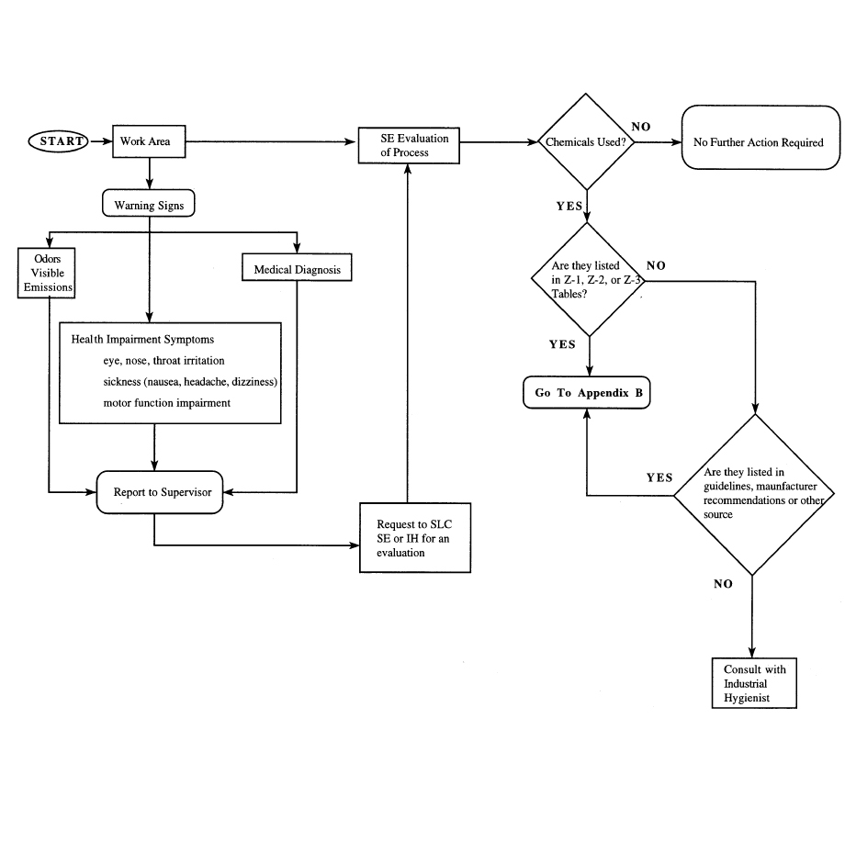

- Exposure Determination and Measurement Flow Chart
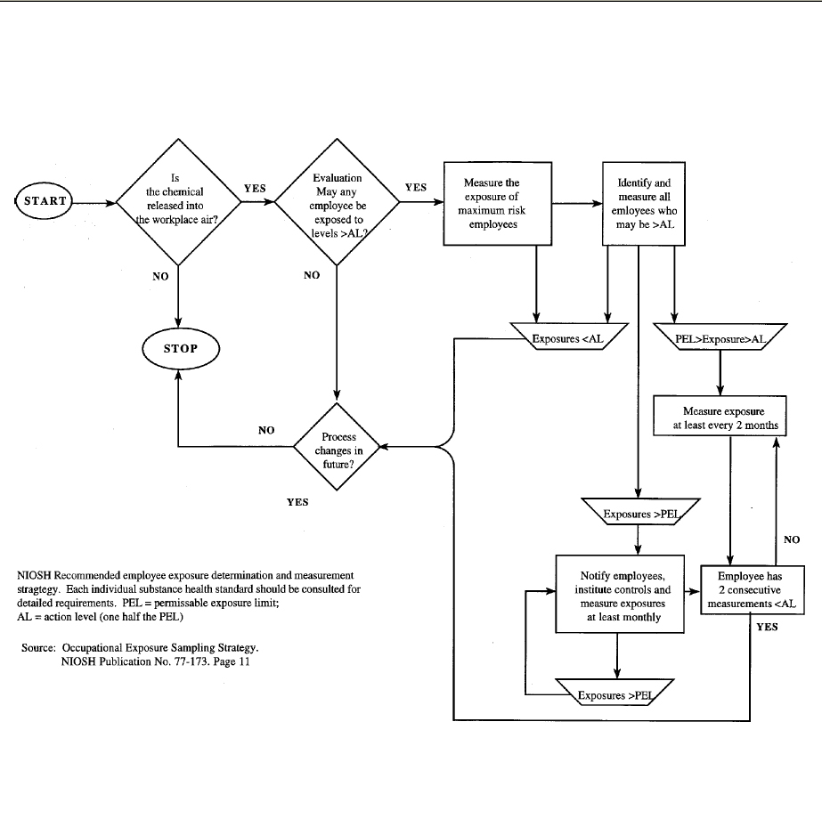

Definitions
ACGIH: American Conference of Governmental Industrial Hygienists.

Administrative Controls: These are non-engineering controls which are used to reduce or eliminate exposure to harmful contaminants. Examples are work rotation, product substitution, pre-employment evaluations, timed exposures, etc.

AIHA: American Industrial Hygiene Association.

Ceiling Values: Concentrations designated by a “c” designation preceding a value which shall not be exceeded at any time during the work shift. If instantaneous readings are not feasible, then the ceiling value shall be assessed based on a 15-minute time interval.

Eight (8) Hour Time Weighted Average (TWA): The amount of exposure determined based on an eight (8) hour exposure. Sampling should be for at least six (6) hours of the eight (8) hour work shift. All substances not designated by a “c” are considered to be an eight (8) hour TWA, Excursion, or Short-Term Exposure Level (STEL). For multiple samples collected during the shift, the TWA is calculated by summing each exposure multiplied by the time interval sampled, and dividing by the total time sampled.

TWA =(C1 x T1)+(C2 x T2)....(Cn x Tn)
T1+T2....Tn

Where:
C = measured concentration for time interval T
T = time interval in minutes

Engineering Controls: An engineered process where contaminants are removed physically from the work area, diluted with air or treated to render innocuous, or are prevented from becoming airborne. Examples are local exhaust ventilation, general ventilation, enclosures, cyclones, scrubbers, and chemical reactors.

SDS: Safety Data Sheet.

Permissible Exposure Limit (PEL): Regulatory limits for contaminants that include the following: Eight-hour TWA, Short Term Exposure Limit (STEL), Ceiling (c), or Excursion Limits.

Qualified Person: Person who has training and experience in air monitoring, exposure assessment, and workplace evaluations.

Threshold Limit Values: Voluntary limits for contaminants as published by the American Conference of Governmental Industrial Hygienists.
Workplace Exposure Evaluation Air monitoring for contaminants by a qualified person (Safety Engineer, Industrial Hygienist) who has training and experience in air monitoring exposure assessment and workplace evaluations.
Work Practices: Specific work procedures that are designed to minimize the release of contaminants to the work area. Examples include wet methods, vacuuming instead of sweeping, slower pace, lower equipment speeds, etc.

V. References: This safety policy and procedure is established in accordance with Occupational Safety and Health Standards for General Industry (29 CFR 1910.1000) and Occupational Safety and Health Standards for Construction Industry (29 CFR1926.1100-1140).

VI. Authors:
Revised by:

Approval/Signature(s):

_________________________________________

